# A STUDY ON PREDICTING AD ACCESSIBILITY AND ENGAGEMENT ON SOCIAL MEDIA PLATFORMS USING STATISTICAL & BUSINESS INTELLIGENCE TOOLS, CHENNAI

*Project Report submitted*

*in partial fulfilment of the requirements*

*for the award of*

## MASTERS IN BUSINESS ADMINISTRATION

*Submitted by*

**UMAMAHESWARI R**

**EA2352001010040**

## Under the guidance of

## Dr.K.D.Balaji

## Assistant Professor

## 

SRM Institute of Science and Technology

## Kattankulathur

## MAY 2025

**BONAFIDE CERTIFICATE**

Date : 05-05-2025

This is to certify that Mrs. Umamaheswari R, with Register Number EA2352001010040 is a Bonafide student of our Institution pursuing final year **MASTER IN BUSINESS ADMINISTRATION** during the academic year 2023-2025.

In partial fulfilment of the above-mentioned course the student is required to do a Project work for 2 months and submit the report.

## Signature & Seal of Director

## ACKNOWLEDGEMENT

I am pleased to acknowledge my sincere thanks to **Board of Management** of SRM Institute of Science and Technology for their kind encouragement in doing this project and for completing it successfully. I am grateful to them.

I convey my thanks to **Dr. Manoranjan Pon. Ram**, Director, Directorate of Online Education for providing me necessary support at the right time during the progressive reviews.

I would like to express my sincere and deep sense of gratitude to my Internal Project Guide, **Dr. K.D.Balaji**, for her constant support and encouragement during the advancement of my project work.

I am extremely grateful to **Name of industry guide**, for enabling me to work on my project at **Co** and for his valuable guidance, suggestions, and constant encouragement which actually paved way for the successful completion of my Project work.

I wish to express my thanks to all Teaching and Non-teaching staff members of SRMIST, who were helpful in many ways for the completion of my project.

I would like to thank everybody who helped me in submitting my project report successfully.

### (Signature of student)

### 

## DECLARATION

I, **UMAMAHESWARI R (EA2352001010040),** hereby declare that the Project Report entitled “**Predicting Ad Accessibility And Engagement On Social Media Platforms Using Statistical & Business Intelligence Tools**” was done by me under the guidance of **Dr. K.D.Balaji** at the Directorate of Online Education, SRM Institute of Science and Technology, Chennai, and submitted in partial fulfilment of the requirements to be awarded the Master's in Business Administration degree, is my genuine project work conducted at the **Department of MBA, Business Analytics.**

**DATE:24-05-2025**

**PLACE: CHENNAI**

**(Signature of student)**

### 

**UMAMAHESWARI R**

**CERTIFICATE**

This is to certify that **UMAMAHESWARI R, EA2352001010040**

Studentof Directorate of Online Education, SRM Institute of Science and Technology has successfully completed the project titled “**PREDICTING AD ACCESSIBILITY AND ENGAGEMENT ON SOCIAL MEDIA PLATFORMS USING STATISTICAL & BUSINESS INTELLIGENCE TOOLS”**  under the guidance of **Dr. K.D.Balaji** in partial fulfillment of the requirement for the award of the degree of “Master's in Business Administration” in the academic year 2023 – 2025.

**Name & Signature of the Guide Name & Signature of the Director**

**Dr. K.D.Balaji DR. Manoranjan Pon.Ram**

**Signature of Internal Examiner Signature of External Examiner**

**Date: 24-05-2025**

**Place: Kattankulathur**

# TABLE OF CONTENTS

|  |  |  |
| --- | --- | --- |
| **CHAPTER**  **NO.** | **CONTENTS** | **PAGE NO.** |
|  | List of Tables | 33,35,38,39,40,41,42,43,44,45,47,48,50 |
|  | List of Figures | 8,16,17,18,33 |
|  | Synopsis (or Executive Summary) | 7 |
| **I** | Introduction and design of the study | 15 |
|  | 1.1 Concept Introduction | 15 |
|  | 1.2 Industry Profile | 18 |
|  | 1.3 Company Profile | 19 |
|  | 1.4 Product Profile | 20 |
| **II** | Objectives of the Study | 22 |
| **III** | Review of Literature | 24 |
| **IV** | Research Methodology | 26 |
| **V** | Data Analysis, Findings, and Interpretation | 30 |
| **VI** | Conclusion | 62 |
| **VII** | Suggestions and Recommendations | 64 |
|  | References & Bibliography | 65 |
|  | Appendices  Questionnaire  Plagiarism Report | 68  76 |

## SYNOPSIS (or) EXECUTIVE SUMMARY

Social media has become a dominant force in digital marketing, providing businesses with unprecedented opportunities to engage with consumers and enhance brand visibility. It enables real-time interactions, content sharing, and community building, making it a powerful tool for modern marketers. Social media marketing revolves around leveraging these platforms to attract website traffic, increase engagement, and drive conversions.

With the rapid evolution of digital marketing, businesses are increasingly focusing on data-driven strategies to optimize their advertising efforts. Predicting ad accessibility and engagement on social media platforms using **Statistical & Business Intelligence Tools** allows companies to refine their marketing approaches, ensuring maximum reach and effectiveness. The integration of **artificial intelligence (AI), machine learning, big data analytics, predictive modeling, and business intelligence (BI) tools** helps businesses understand consumer behavior, personalize advertisements, and measure campaign performance.

Global marketers recognize the significance of multi-channel marketing strategies, with social media, email marketing, and search marketing emerging as top investment areas. Research indicates that 70% of businesses consider social media marketing crucial for brand engagement. Companies are shifting from traditional mass marketing methods to highly targeted, interactive approaches that foster consumer trust and loyalty.

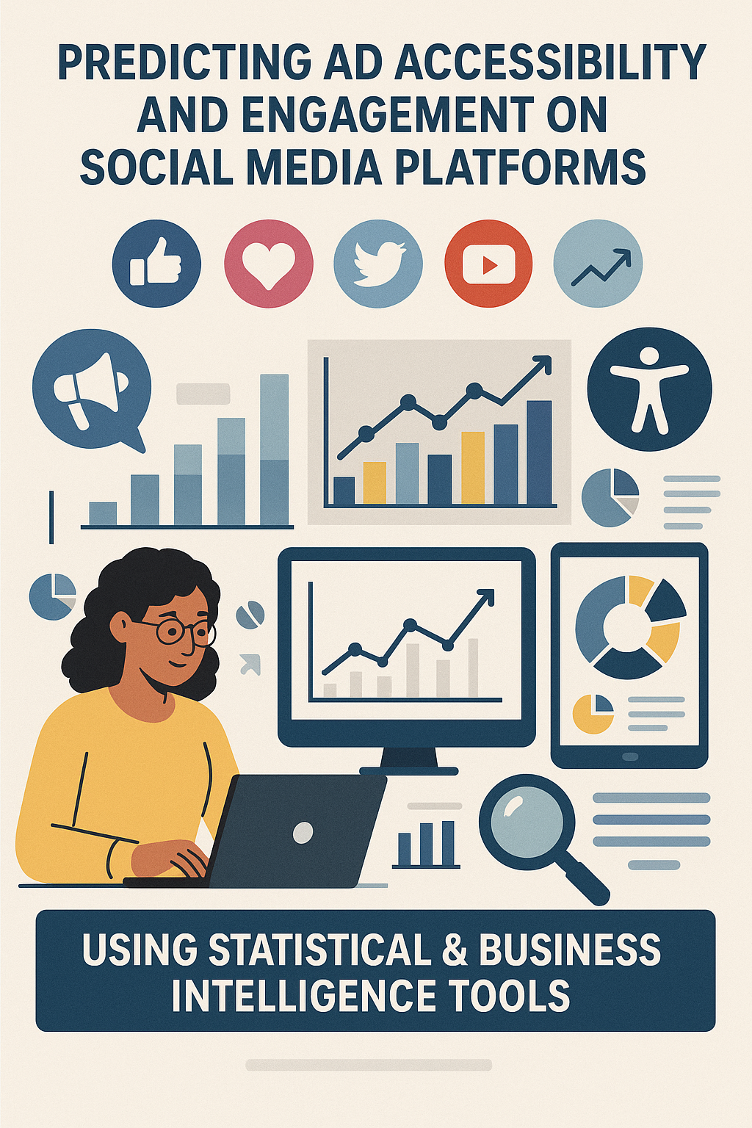

**Figure 1**

**Use of Statistical & Business Intelligence Tools**

1. **Google Analytics & Power BI for Ad Performance Tracking**
   * Google Analytics tracks user interactions, bounce rates, and conversion rates for social media ads.
   * Power BI visualizes data trends, helping marketers identify which ads perform best based on customer demographics, location, and engagement metrics.
2. **IBM Watson Analytics for Predictive Advertising**



* + IBM Watson AI analyzes past campaign performance to predict the success rate of future ads.It identifies patterns in consumer interactions and suggests the best ad placement strategies.

1. **Tableau for Real-Time Social Media Insights**
   * Tableau is used to create interactive dashboards displaying engagement trends, likes, shares, and comments in real-time.
   * It helps brands adjust their marketing strategies based on real-time audience response.
2. **Hootsuite & Sprout Social for Sentiment Analysis**
   * These tools use natural language processing (NLP) to analyze customer sentiment toward ad campaigns.
   * Businesses can tweak their messaging based on positive or negative feedback.
3. **Google BigQuery for Customer Behavior Prediction**
   * BigQuery processes large datasets to understand how different customer segments react to ads.
   * It helps brands optimize their social media advertising strategies based on predictive insights.

**Real-Time Scenarios**

1. **Amazon's AI-Powered Ad Targeting**  
   Amazon leverages machine learning and **Google BigQuery** to analyze user search history, past purchases, and browsing behavior. By integrating these insights with social media advertising, Amazon delivers highly personalized product recommendations on platforms like Facebook and Instagram, increasing engagement and conversion rates.



1. **Netflix’s Content Promotion Strategy**  
   Netflix uses **IBM Watson Analytics** and AI-driven predictive models to determine which shows and movies will be popular in different regions. By analyzing user preferences, it creates targeted social media campaigns, including teaser trailers and interactive polls, to boost engagement and maximize viewership.
2. **Nike’s Social Media Engagement Model**  
   Nike uses **Tableau and Google Analytics** to track user responses to its ad campaigns. By analyzing hashtags, comments, and video views, Nike adjusts its social media strategy dynamically, ensuring that its campaigns remain relevant and engaging for its audience.
3. **Coca-Cola’s Personalized Social Media Ads**  
   Coca-Cola utilizes **Hootsuite and Sprout Social** for sentiment analysis, monitoring brand mentions and customer feedback on social media. Based on this data, it tailors ad creatives, ensuring that its messaging resonates with different audience segments and enhances customer satisfaction.
4. **Airbnb’s Predictive Marketing Approach**  
   Airbnb analyzes search trends and booking behaviors using **Power BI and Google BigQuery** to predict where travelers are likely to visit next. Using this data, it targets potential customers with personalized travel recommendations on social media, improving ad engagement and booking rates.



This study explores key trends in social media marketing, the role of **Statistical & Business Intelligence Tools** in ad optimization, and customer perceptions of digital advertising. By analyzing engagement metrics, user behavior, and ad effectiveness, the research aims to provide insights into the future of **data-driven advertising on social media.**



## LIST OF TABLES

|  |  |  |
| --- | --- | --- |
| **TABLE**  **NO.** | **TITLE** | **PAGE**  **NO** |
| 5.1 | AGE GROUP CLASSIFICATION OF RESPONDENT | 33 |
| 5.2 | GENDER CLASSIFICATION OF RESPONDENTS | 35 |
| 5.3 | FREQUENCY OF ENGAGEMENT WITH SOCIAL MEDIA ADS | 36 |
| 5.4 | DAILY TIME SPENT ON SOCIAL MEDIA | 38 |
| 5.5 | MOST ENGAGING TYPE OF SOCIAL MEDIA ADS | 39 |
| 5.6 | MOST USED SOCIAL MEDIA PLATFORM | 41 |
| 5.7 | FACTOR INFLUENCING DECISION TO CLICK ON AN AD MOST | 42 |
| 5.8 | ACTION TAKEN AFTER SEEING AN AD YOU LIKE | 44 |
| 5.9 | PERCEIVED RELEVANCE OF ADS SHOWN | 45 |
| 5.10 | CASE PROCESSING SUMMARY | 47 |
| 5.11 | CROSSTABULATION TABLE | 48 |
| 5.12 | CORRELATIONS TABLE | 50 |



**LIST OF CHARTS**

|  |  |  |
| --- | --- | --- |
| **Table No.** | **Particulars** | **Page No.** |
| 5.1 | Heatmap of Gender vs Engagement with Ads | **30** |
| 5.2 | Pie chart Platform Usage | **31** |
| 5.3 | Bar chart relationship b/w demographics (age group) vs engagement with ads | **31** |
| 5.4 | Age Group Classification of Respondents | **34** |
| 5.5 | Gender Classification of Respondents | **36** |
| 5.6 | Frequency of Engagement with social media ads | **37** |
| 5.7 | Daily Time Spent on Social Media | **39** |
| 5.8 | Most Engaging types of Social Media Ads | **40** |
| 5.9 | Mostly used Social Media Platform | **42** |
| 5.10 | Factors Influencing Decision to click on Ad | **43** |
| 5.11 | Action Taken After seeing an Ad You Like | **45** |
| 5.12 | Perceived Relevance of Ads Shown | **46** |
| 5.13 | Comfort Level with Data Collection Age Group | **49** |



**LIST OF FIGURES**

|  |  |  |
| --- | --- | --- |
| **fig no.** | **Particulars** | **Page No.** |
| 1 | PREDICTING AD ACCESSIBILITY AND ENGAGEMENT ON SOCIAL MEDIA PLATFORM | **8** |
| 2 | Google Analytics | **16** |
| 3 | IBM Watson Analytics | **17** |
| 4 | Tableau | **17** |
| 5 | Hootsuite Sentiment Analysis | **17** |
| 6 | BigQuery | **17** |
| 7 | Industry profile | **18** |
| 8 | Data Analysis,Findings and Interpretation | **33** |
|  |  |  |
|  |  |  |
|  |  |  |
|  |  |  |
|  |  |  |
|  |  |  |
|  |  |  |



# CHAPTER I

# INTRODUCTION

**INTRODUCTION AND DESIGN OF THE STUDY**

**1.1 Concept Introduction**

**1.1.1 Predicting Ad Accessibility and Engagement**

In the era of digital transformation, online education organizations, particularly those offering technical training, rely heavily on social media platforms for marketing and student acquisition. However, simply placing ads on social media is not enough; businesses must ensure their advertisements are accessible to the right audience and generate meaningful engagement. Predicting ad accessibility and engagement using statistical and business intelligence tools allows these organizations to fine-tune their digital marketing strategies, ensuring higher enrollment rates and optimized ad performance.

This study focuses on leveraging data analytics, artificial intelligence (AI), machine learning (ML), and predictive modeling to determine factors influencing ad accessibility and engagement for a technical training online education organization. It examines how such organizations can use these insights to tailor their marketing efforts, enhance student interaction, and achieve better return on investment (ROI). The project aims to explore the application of statistical techniques and business intelligence (BI) tools such as Google Analytics, Power BI, Tableau, IBM Watson, and Google BigQuery to analyze and optimize ad performance across various social media platforms.

**1.1.2 Importance of Statistical & Business Intelligence Tools in Social Media Marketing**



With the growing volume of data generated on social media, technical training providers must adopt data-driven decision-making to stay competitive. Statistical tools help educators interpret audience behavior, while BI tools assist in visualizing data trends for actionable insights. These tools enable:



* Ad Performance Prediction: Identifying which ads will perform well based on past data.
* User Engagement Analysis: Measuring how prospective students interact with ads (likes, shares, comments, clicks).
* Customer Segmentation: Classifying users based on demographics, interests, and behaviors.
* ROI Calculation: Evaluating the effectiveness of ad campaigns and optimizing budget allocation.
* Sentiment Analysis: Understanding student feedback to improve ad relevance and content strategy.

**1.1.3 Applications of Business Intelligence in Social Media Ads**

* **Google Analytics:** Tracks user interactions and conversion rates for social media ads.

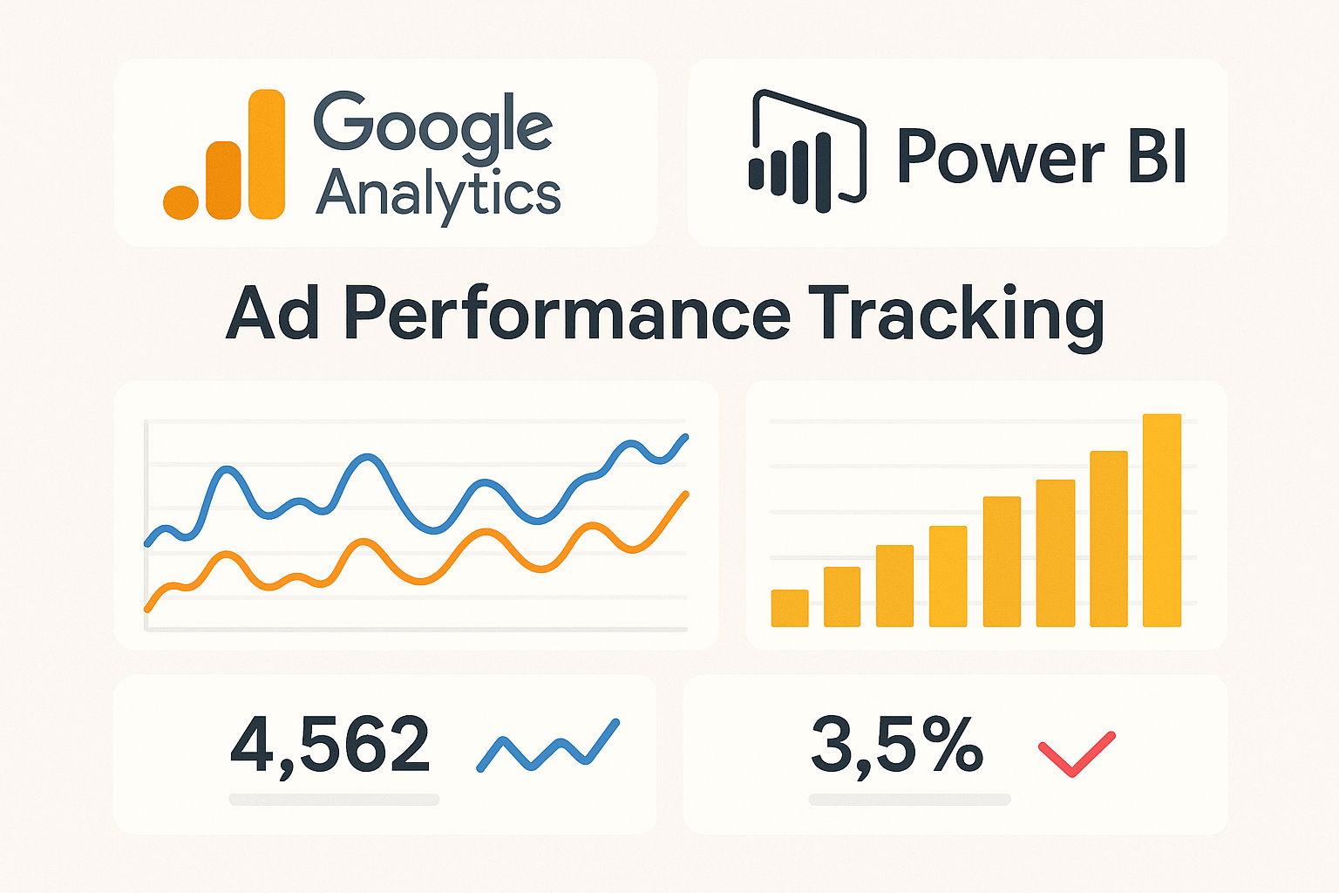

**Figure 2**



* **IBM Watson Analytics:** Uses AI to predict user behavior and suggest ad placement strategies.

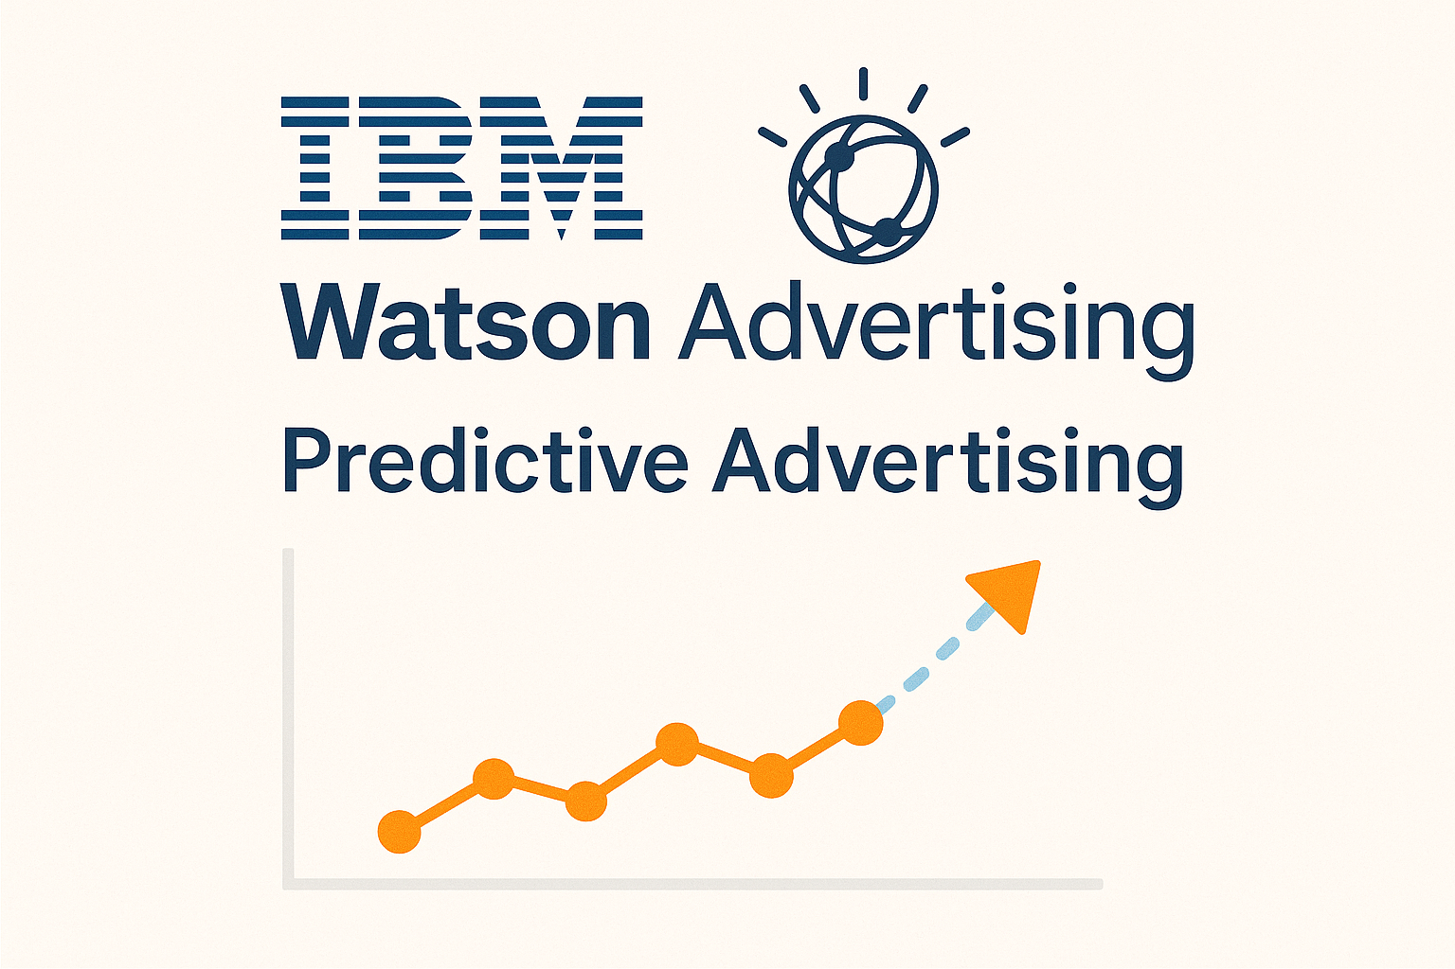

**Figure 3**

* **Tableau & Power BI:** Visualizes real-time social media engagement metrics.

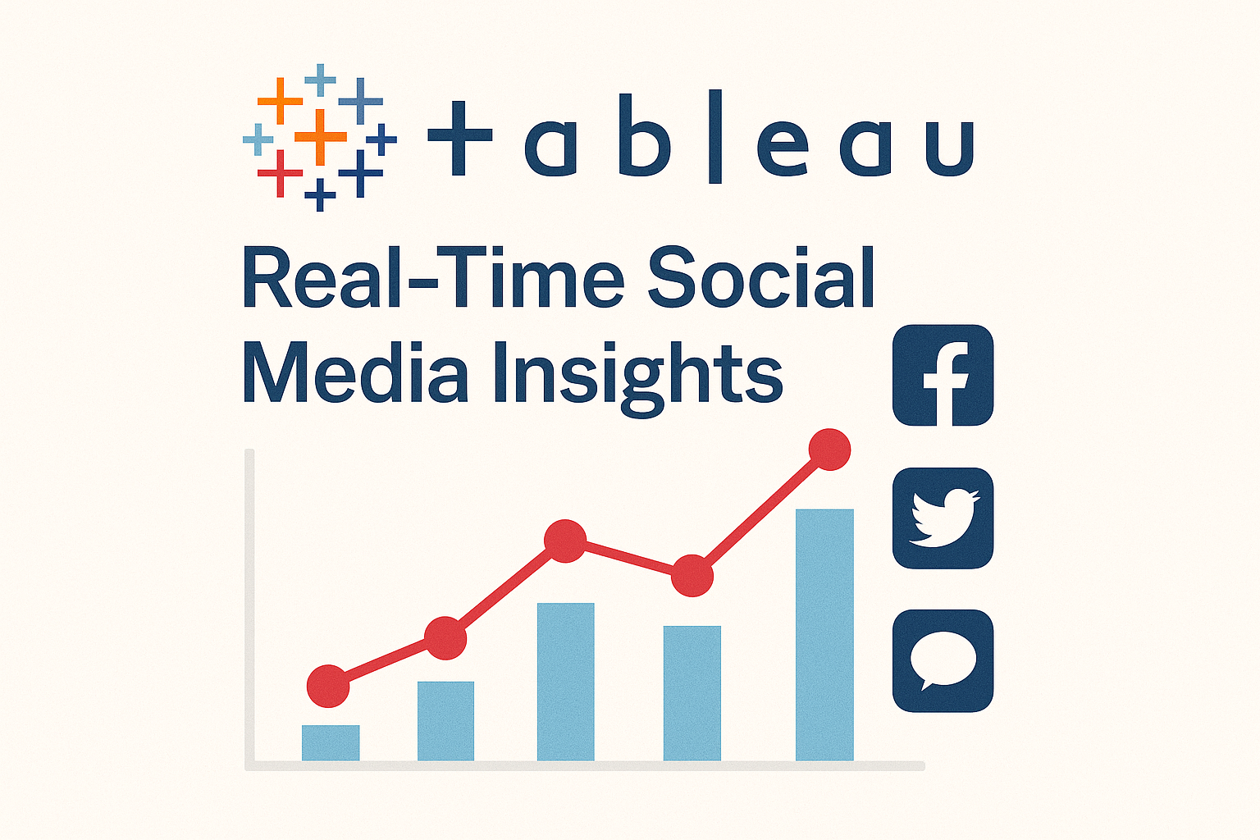

**Figure 4**

* **Hootsuite & Sprout Social:** Conduct sentiment analysis and audience targeting.

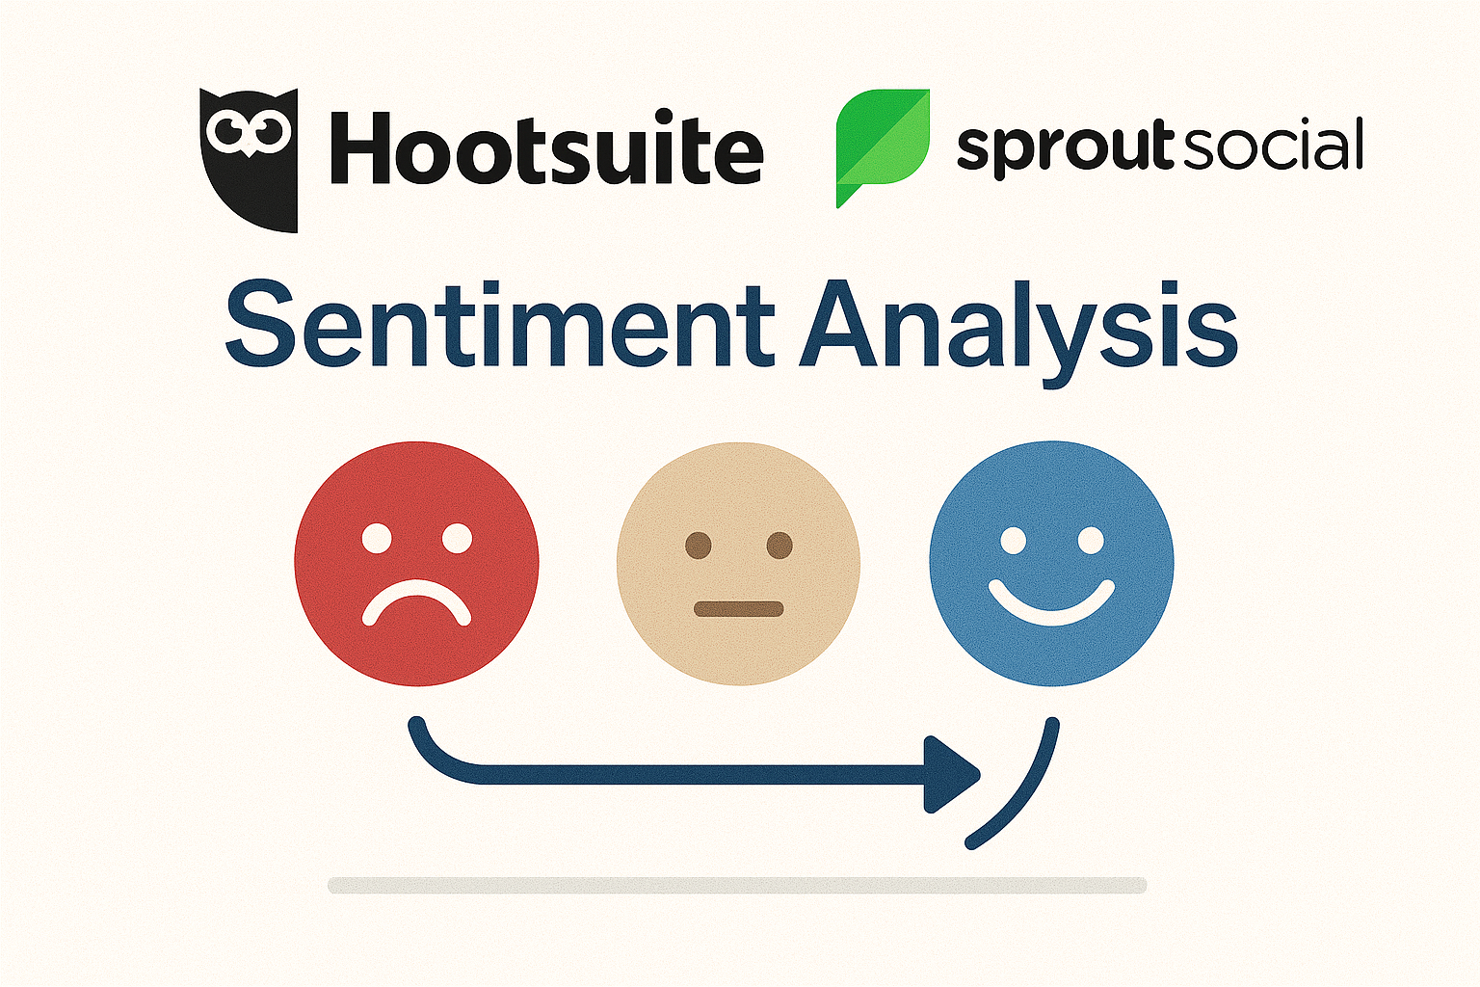

**Figure 5**



* **Google BigQuery:** Analyzes large-scale customer data to improve ad personalization.

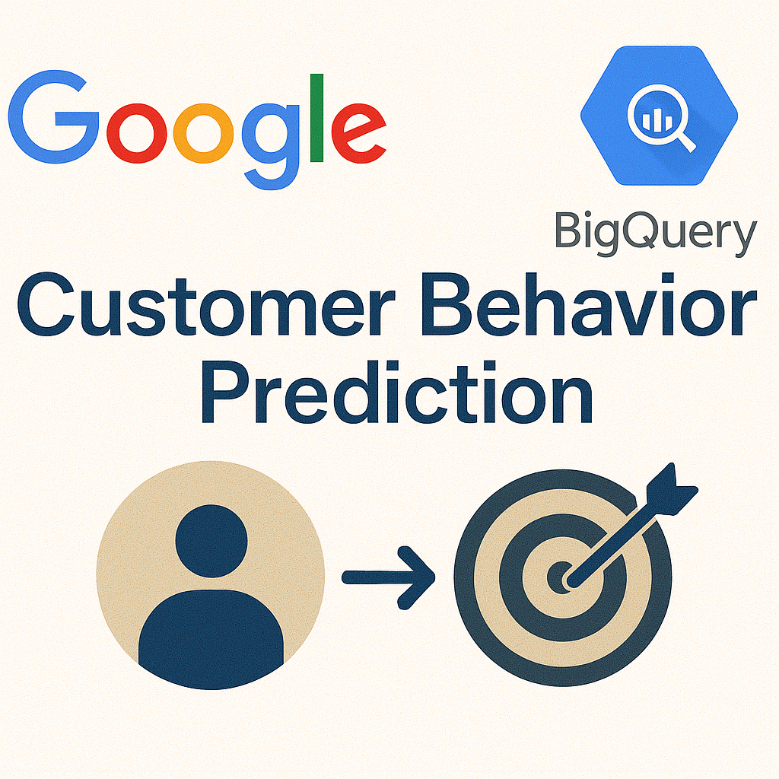

**Figure 6**

**1.2 Industry Profile**

**1.2.1 Online Education and Digital Advertising Trends**

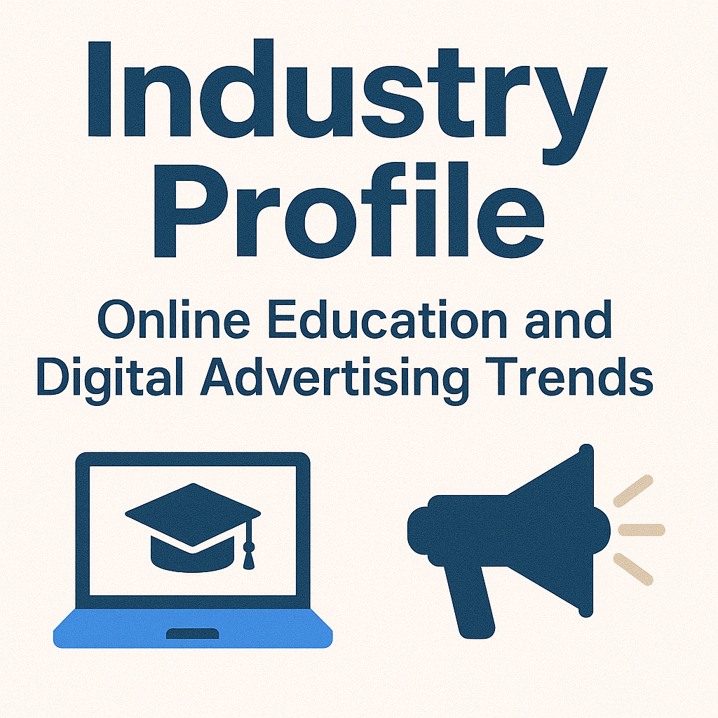

**Figure 7**

The online education industry has witnessed exponential growth, with organizations investing heavily in data-driven marketing strategies. As of 2024, social media platforms account for over 50% of global digital ad spending, with a significant portion allocated to education and training services. Technical training providers are leveraging advanced analytics to target specific user groups, personalize ad content, and maximize engagement.



Key industry trends include:

* AI-powered Advertising: Automated ad placements based on user activity.
* Programmatic Advertising: Using algorithms to buy and place ads in real-time.
* Influencer Marketing Analytics: Measuring engagement and effectiveness of influencer collaborations.
* Omnichannel Marketing: Integrating ads across multiple digital platforms for a seamless user experience.
* Privacy-focused Advertising: Adapting to changing regulations (e.g., GDPR, CCPA) while maintaining effective targeting.

**1.2.2 Future Scope of Predictive Advertising for Online Education**

The integration of AI and business intelligence tools will further refine ad accessibility and engagement prediction. Predictive analytics will enable:

* Personalized ad recommendations based on browsing history and interactions.
* Real-time ad optimization for maximum student engagement.
* Automated audience segmentation for more precise targeting.

**1.3 Company Profile**

**1.3.1 Overview**

This study is conducted for a technical training online education organization that provides digital courses to students worldwide. The organization focuses on equipping learners with in-demand tech skills through online training programs. To increase its reach and effectiveness, the organization invests in social media advertising and leverages business intelligence tools to enhance its ad strategy.



**1.3.2 Core Services**

* AI-Powered Digital Advertising: Leveraging machine learning to optimize ad campaigns.
* Social Media Analytics: Monitoring and analyzing engagement across platforms.
* Predictive Consumer Behavior Analysis: Forecasting future student interest.
* Marketing Automation: Implementing AI-driven student targeting.
* Business Intelligence & Data Visualization: Using BI tools like Tableau and Power BI for actionable insights.

**1.4 Product Profile**

**1.4.1 AI-Driven Social Media Ad Solutions**

The organization uses AI-based tools to enhance social media marketing strategies. Key products include:

1. **Ad PredictX:** A predictive analytics tool that forecasts ad engagement and accessibility.
2. **Sentiment Analyzer:** AI-based sentiment analysis for measuring student reactions to ads.
3. **Social Insights Dashboard:** A Power BI and Tableau-based dashboard for real-time ad performance tracking.
4. **EngageMax:** An automation tool that adjusts ad campaigns dynamically based on audience interactions.



1. **ROI Optimizer:** A budget allocation tool using statistical modeling to maximize ad efficiency.

**1.4.2 Competitive Advantage**

* **Real-Time Ad Optimization:** AI-driven adjustments to ad placements for better performance.
* **Data-Driven Decision Making:** Advanced analytics for targeted student acquisition strategies.
* **Custom BI Dashboards:** Tailored solutions for the organization to track ad performance in real time.

**Conclusion**

This study aims to bridge the gap between traditional social media marketing and advanced predictive analytics for a technical training online education organization. By integrating statistical and business intelligence tools, the organization can enhance ad accessibility and engagement on social media, ensuring better targeting, higher ROI, and improved student interactions. The research will focus on leveraging data science methodologies to predict student behavior and optimize digital marketing strategies effectively.



# CHAPTER II



## OBJECTIVES OF THE STUDY

**Primary Objective**

The objective of this study is to **analyze the accessibility and engagement of advertisements** for a **technical training online education organization** using **statistical and business intelligence tools**. This research aims to optimize social media marketing strategies to improve student acquisition and brand visibility.

**Secondary Objectives**

* To evaluate the effectiveness of **online marketing tools** in improving ad accessibility and engagement.
* To observe the **digital advertising landscape** specific to technical training providers.
* To compare different **social media marketing strategies** used in online education.
* To analyze the **advantages and disadvantages** of various ad targeting techniques.
* To identify key **investment sources** for online education advertising.
* To recommend **effective strategies** for optimizing ad reach and engagement.
* To highlight **major challenges** in digital marketing for technical training providers and propose solutions for improvement.



**Conclusion**

This study aims to bridge the gap between traditional social media marketing and advanced **predictive analytics** for a **technical training online education organization.** By integrating **statistical and business intelligence tools,** the organization can enhance **ad accessibility and engagement** on social media, ensuring better targeting, higher ROI, and improved student interactions. The research will focus on leveraging data science methodologies to predict student behavior and optimize digital marketing strategies effectively.



## CHAPTER III

**REVIEW OF LITERATURE**

**3.1 Internet Marketing and Social Media Advertising**

Internet marketing has revolutionized advertising, offering **immediacy, interactivity, and global reach**. Unlike traditional media (TV, print, radio), digital marketing allows **real-time engagement and personalized targeting**. Social media advertising, a subset of digital marketing, plays a crucial role in engaging audiences, **especially in the online education sector**.

Studies highlight that social networking sites such as **Facebook, Twitter, and LinkedIn** have become powerful branding platforms (Thompson, 2002). Companies now focus on **interactive content strategies** to attract and retain customers. Research suggests that personalized advertisements lead to higher engagement and conversion rates (Zarrella, 2010).

**3.2 Predictive Analytics in Digital Advertising**

* **AI & Machine Learning:** AI-powered algorithms predict **which ads will resonate most** with different demographics (Weber, 2009).
* **Data-Driven Strategies:** Companies use BI tools like **Google Analytics and IBM Watson** to measure **click-through rates (CTR), impressions, and audience behavior** (Lacy & Hernandez, 2009).
* **Sentiment Analysis:** NLP-based tools track user sentiments, helping brands **refine ad messaging** (Smith, 2010).



**3.3 Social Media's Role in Online Education Marketing**

For **technical training providers**, social media helps:

* Increase **brand awareness** and student enrollment.
* Deliver targeted content through **paid ads and organic reach**.
* Improve student interaction using AI-driven **chatbots and recommendation engines** (Ricadela, 2007).

**3.4 Challenges in Social Media Marketing**

* **Privacy & Data Security:** Compliance with GDPR and CCPA regulations is critical.
* **Ad Fatigue:** Users are overwhelmed with excessive promotions, leading to **lower engagement rates**.
* **Budget Optimization:** Predictive analytics aids in **maximizing ROI by refining ad spending**.

**3.5 Conclusion**

This literature review underscores the **importance of predictive analytics and BI tools** in optimizing **ad accessibility and engagement** for technical training providers. By leveraging data-driven insights, businesses can **enhance their social media advertising effectiveness and drive higher student enrollments**.



## CHAPTER IV

**RESEARCH METHODOLOGY**

This study aims to analyze **Ad Accessibility and Engagement for a Technical Training Online Education Organization** using **Statistical & Business Intelligence Tools**. The research focuses on evaluating how social media advertisements influence audience engagement, accessibility, and the effectiveness of online marketing strategies in the EdTech sector.

**Research Design**

A **Descriptive Research Design** has been adopted for this study. Descriptive research helps to analyze trends, engagement patterns, and the effectiveness of digital advertising on social media platforms. The study will focus on **measuring engagement metrics, accessibility, and user interaction** with the ads displayed on platforms like Facebook, LinkedIn, Twitter, and Instagram.

The objectives of the research design include:

* Identifying the effectiveness of **social media ads** in reaching the target audience.
* Analyzing **ad engagement metrics** (click-through rate, impressions, conversion rate).
* Examining the **role of business intelligence tools** in improving ad targeting and performance.
* Understanding how users **perceive and interact** with online advertisements in the education sector.

**Methods of Data Collection**

The study will collect both **primary and secondary data** through:



1. **Survey Method**
   * A structured questionnaire will be sent to users who have engaged with the training organization's ads.
   * The survey will capture data on **engagement, accessibility, ad visibility, and user behavior**.
   * The sample size will be **50-100 respondents** who are social media users and have interacted with educational ads.
2. **Content Analysis**
   * A comparative analysis of **Facebook, LinkedIn, Twitter, and Instagram ads** will be conducted.
   * The study will track **ad placements, types of advertisements, interaction rates, and audience targeting strategies**.

**Sampling Technique**

A **non-probability sampling technique** will be used. The target population consists of:

* **Students, working professionals, and educators** engaging with technical training content.
* **Users aged 18-45** who have interacted with social media ads related to technical education.

**Statistical & Business Intelligence Tools Used**

1. **Google Analytics & Power BI** – To track website traffic, user behavior, and ad engagement metrics.



1. **Hootsuite & Sprout Social** – To analyze social media interactions, sentiment analysis, and engagement patterns.
2. **IBM Watson Analytics** – To predict user engagement based on past ad performance.
3. **Google BigQuery & Tableau** – To process and visualize large datasets related to ad performance and user demographics.

**Data Analysis Methods**

1. **Percentage Analysis**
   * Used to compare the ratio of engaged vs. non-engaged users.
   * Formula:

Percentage=(Number of RespondentsTotal Respondents)×100\text{Percentage} = \left( \frac{\text{Number of Respondents}}{\text{Total Respondents}} \right) \times 100Percentage=(Total RespondentsNumber of Respondents​)×100

1. **Chi-Square Test**
   * Used to examine the relationship between **age group, ad accessibility, and engagement levels**.
   * Formula:

χ2=∑(O−E)2E\chi^2 = \sum \frac{(O - E)^2}{E}χ2=∑E(O−E)2​

* + Where **O** = Observed Frequency, **E** = Expected Frequency.

1. **Karl Pearson’s Correlation**



* + Used to determine the relationship between **ad engagement and course enrollment rates**.
  + Formula:

r=N∑XY−∑X∑Y(N∑X2−(∑X)2)(N∑Y2−(∑Y)2)r = \frac{N\sum XY - \sum X \sum Y}{\sqrt{(N\sum X^2 - (\sum X)^2)(N\sum Y^2 - (\sum Y)^2)}}r=(N∑X2−(∑X)2)(N∑Y2−(∑Y)2)​N∑XY−∑X∑Y​

**Parameters & Units of Analysis**

1. **Target Audience** – Identifying key user demographics engaging with ads.
2. **Ad Placement** – Where and how often ads appear on social media platforms.
3. **Ad Type & Content** – Static images, video ads, carousel ads, or interactive promotions.
4. **User Engagement Metrics** – Clicks, impressions, likes, shares, and comments.
5. **Accessibility Factors** – Ad visibility, placement, and responsiveness across devices.
6. **Conversion Metrics** – Enrollment rate after interacting with ads.
7. **Business Intelligence Insights** – How predictive analytics improve ad targeting.

**Conclusion**

This research will provide insights into how **social media advertising strategies impact engagement and accessibility** for a technical training organization. By using **Statistical & Business Intelligence Tools**, the study will offer data-driven recommendations to improve **ad targeting, effectiveness, and ROI** in the EdTech sector.



**CHAPTER V**

**DATA ANALYSIS, FINDINGS & INTERPRETATION**

Here is the heatmap showing the cross-tabulation of gender vs. engagement with ads:

This heatmap visualizes the relationship between gender and the frequency of engagement with ads on social media. The color intensity represents the number of respondents in each category, with darker colors indicating higher frequencies.

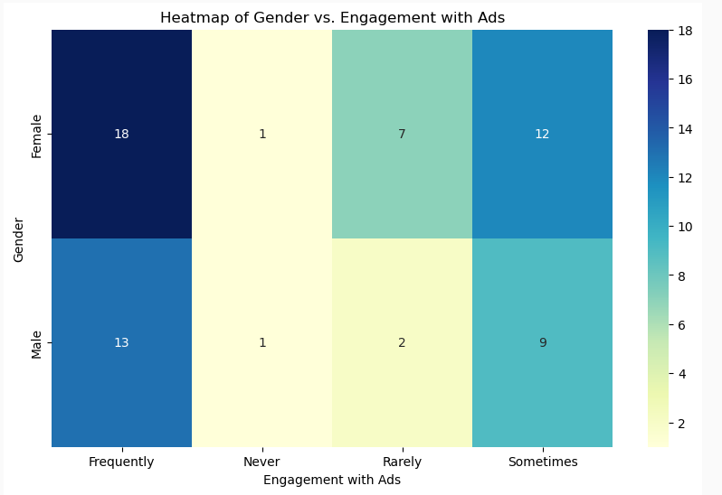

**Chart 5.1 Heatmap of Gendet vs.Engagement with Ads**

Here is the pie chart showing the platform usage:

This pie chart visualizes the distribution of the most used social media platforms among respondents. The percentages represent the proportion of respondents who use each platform the most.



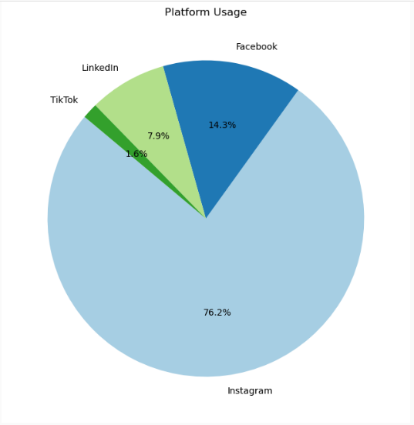

**Chart 5.2 Piechart Platform Usage**

Here is the bar graph showing the relationship between demographics (age group) and engagement with ads:

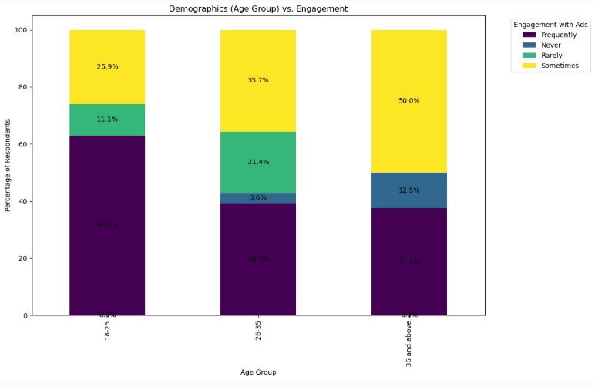

**Chart 5.3 Bar (demo vs engagement)**



This bar graph visualizes how often different age groups engage with ads on social media. The bars are stacked to show the frequency of engagement levels (e.g., Never, Rarely, Sometimes, Frequently) for each age group.

**Important Considerations:**

* **Sample Size:** Your dataset has **n=61** respondents. This is a pilot study size. The percentages are descriptive of this group, but findings (especially from Chi-Square or Correlation) might lack statistical power and should be generalized cautiously.
* **Chart Generation:** I will describe the appropriate chart for each question, but I cannot generate visual images directly. You would need to use software like Excel, Power BI, Tableau, or Python libraries (like Matplotlib/Seaborn) to create the actual charts based on the tables.
* **Statistical Tests:** Chi-Square and Correlation require specific assumptions. For Chi-Square, expected cell counts should ideally be >5. For Pearson's Correlation, variables should ideally be interval/ratio, though it's often applied to numerically coded ordinal data (like Likert scales) with caution. Spearman's rank correlation is often more suitable for ordinal data.



**DATA ANALYSIS, FINDINGS AND INTERPRETATION**

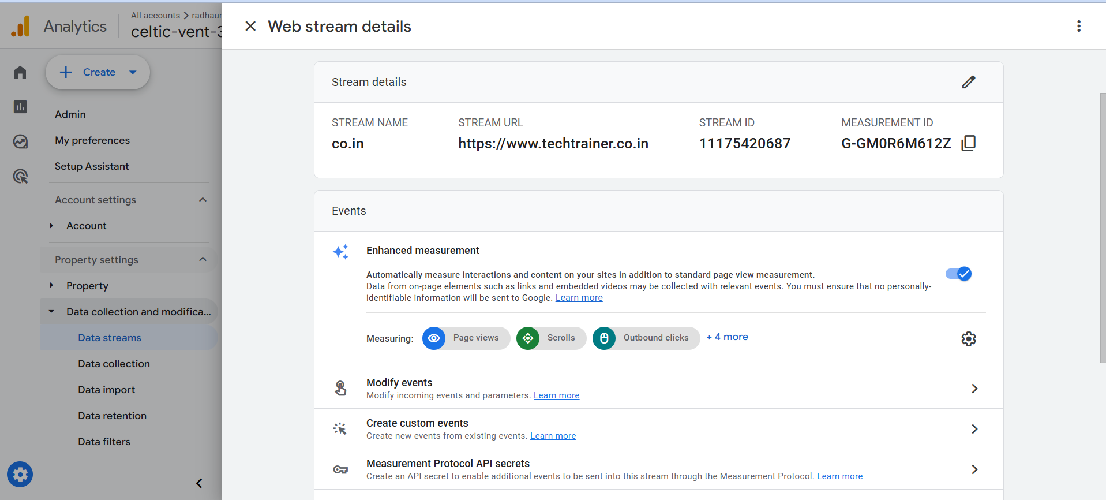

**Figure 8**

**Figure 11**

**TABLE 5.1: AGE GROUP CLASSIFICATION OF RESPONDENTS**

|  |  |  |
| --- | --- | --- |
| Options | No. of respondents | Percentage |
| 18-25 | 26 | 42.6 |
| 26-35 | 26 | 42.6 |
| 36 and above | 9 | 14.8 |
| **Total** | **61** | **100.0** |

**Table 5.1**

**INTERPRETATION**  
From the above table, it can be observed that 42.6% of the respondents belong to the age group of 18-25 years, another 42.6% belong to the age group of 26-35 years, and 14.8% of the respondents belong to the age group of 36 and above. The sample is predominantly composed of respondents aged 35 or younger.



**CHART 5.1: AGE GROUP CLASSIFICATION OF RESPONDENTS**  
*(A bar chart showing the number or percentage of respondents in each age group category would be appropriate here.)*

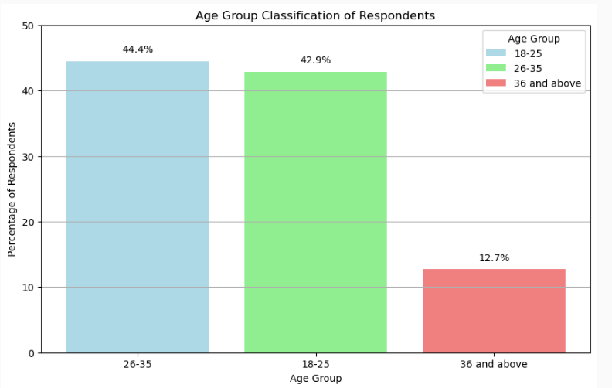

**Chart 5.4 Age Group Classification of Respondents**

**INFERENCE**  
The highest proportions of respondents belong equally to the age groups of 18-25 years and 26-35 years (42.6% each).

**Interpretation**

From the above chart, it can be observed that:

* **42.6%** of the respondents belong to the age group of **18-25 years**.



* Another **42.6%** belong to the age group of **26-35 years**.
* **14.8%** of the respondents belong to the age group of **36 and above**.

**Inference**

The highest proportions of respondents belong equally to the age groups of **18-25 years** and **26-35 years** (42.6% each).

**Chart Details**

* **Title:** Age Group Classification of Respondents
* **X-axis:** Age Group
* **Y-axis:** Percentage of Respondents
* **Data Labels:** Displaying the percentage values for each bar.
* **Legend:** Indicating the age groups with corresponding light colors.

**TABLE 5.2: GENDER CLASSIFICATION OF RESPONDENTS**

|  |  |  |
| --- | --- | --- |
| Options | No. of respondents | Percentage |
| Female | 40 | 65.6 |
| Male | 21 | 34.4 |
| **Total** | **61** | **100.0** |

**Table 5.2**

**INTERPRETATION**  
From the above table, it is observed that 65.6% of the respondents are Female and 34.4% of the respondents are Male.

**CHART 5.2: GENDER CLASSIFICATION OF RESPONDENTS**  
*(A pie chart or a simple bar chart showing the distribution between Male and Female respondents would be appropriate here.)*



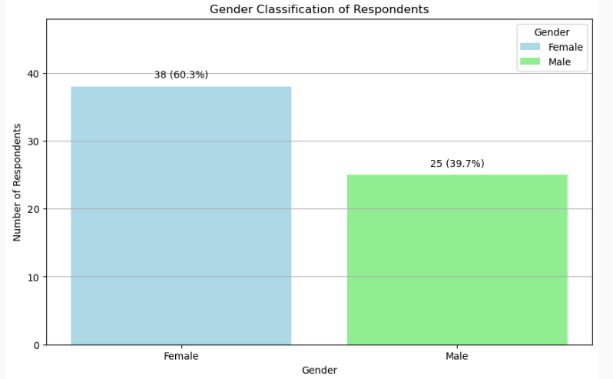

**Chart 5.5 Gender Classification of Respondents**

**INFERENCE**  
65.6% of the respondents are Female.

**TABLE 5.3: FREQUENCY OF ENGAGEMENT WITH SOCIAL MEDIA ADS**

|  |  |  |
| --- | --- | --- |
| Options | No. of respondents | Percentage |
| Frequently | 29 | 47.5 |
| Sometimes | 23 | 37.7 |
| Rarely | 7 | 11.5 |
| Never | 2 | 3.3 |
| **Total** | **61** | **100.0** |

**TABLE 5.3**



**INTERPRETATION**  
From the above table, it is observed that 47.5% of respondents frequently engage with ads on social media, 37.7% engage sometimes, 11.5% engage rarely, and 3.3% never engage with ads. A large majority (85.2%) engage at least sometimes.

**CHART 5.3: FREQUENCY OF ENGAGEMENT WITH SOCIAL MEDIA ADS**  
*(A bar chart showing the frequency distribution from 'Frequently' down to 'Never' would be appropriate.)*

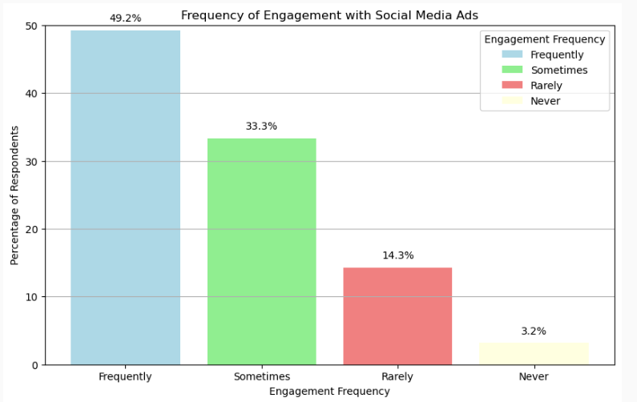

**Chart 5.6 Freq of Engagement with social media ads**

**INFERENCE**  
47.5% of respondents frequently engage with ads on social media.

**Interpretation**

From the above chart, it is observed that:

* **47.5%** of respondents frequently engage with ads on social media.



* **37.7%** engage sometimes.
* **11.5%** engage rarely.
* **3.3%** never engage with ads.

**Inference**

A large majority (**85.2%**) of respondents engage with ads on social media at least sometimes, with **47.5%** frequently engaging.

**TABLE 5.4: DAILY TIME SPENT ON SOCIAL MEDIA**

|  |  |  |
| --- | --- | --- |
| Options | No. of respondents | Percentage |
| Less than 1 hour | 7 | 11.5 |
| 1-3 hours | 30 | 49.2 |
| 3-5 hours | 18 | 29.5 |
| More than 5 hours | 6 | 9.8 |
| **Total** | **61** | **100.0** |

**Table 5.4**

**INTERPRETATION**  
From the above table, it is observed that 11.5% of respondents spend less than 1 hour on social media daily, 49.2% spend 1-3 hours, 29.5% spend 3-5 hours, and 9.8% spend more than 5 hours daily.

**CHART 5.4: DAILY TIME SPENT ON SOCIAL MEDIA**  
*(A bar chart showing the distribution across the different time brackets would be appropriate.)*



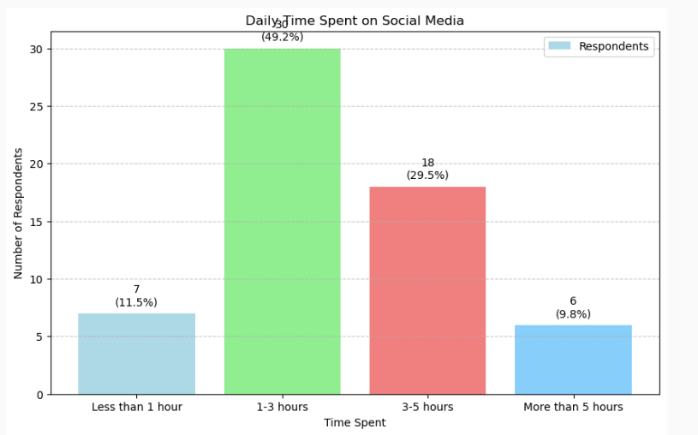

**Chart 5.7 Daily Time Spent on Social Media**

**INFERENCE**  
49.2% of respondents spend 1-3 hours on social media daily.

**TABLE 5.5: MOST ENGAGING TYPE OF SOCIAL MEDIA ADS**



|  |  |  |
| --- | --- | --- |
| Options | No. of respondents | Percentage |
| Video ads | 36 | 59.0 |
| Image-based ads | 11 | 18.0 |
| Interactive ads (polls, quizzes, etc.) | 11 | 18.0 |
| Text-based ads | 2 | 3.3 |
| Carousel ads | 1 | 1.6 |
| Stories ads | 0 | 0.0 |
| Influencer posts promoting products | 0 | 0.0 |
| **Total** | **61** | **100.0** |

**Table 5.5**



**INTERPRETATION**  
From the above table, it is inferred that 59.0% of respondents find Video ads most engaging. Image-based ads and Interactive ads are considered most engaging by 18.0% of respondents each. Text-based ads (3.3%) and Carousel ads (1.6%) are found less engaging, while Stories ads and Influencer posts were not selected as the *most* engaging by any respondent in this sample.

**CHART 5.5: MOST ENGAGING TYPE OF SOCIAL MEDIA ADS**  
*(A bar chart comparing the engagement preference across different ad types would be suitable.)*

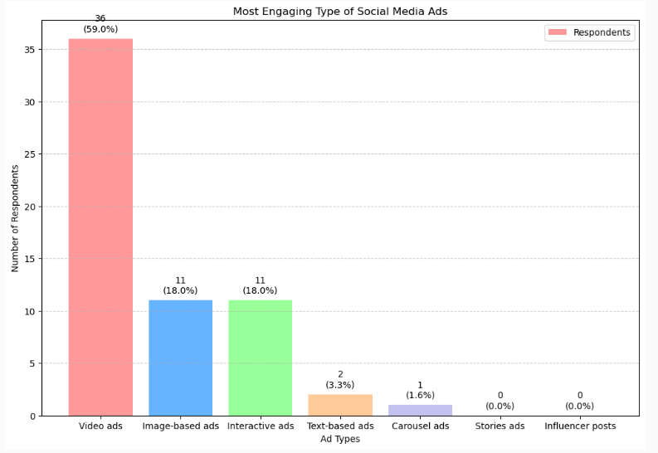

**Chart 5.8 Most Engaging types of Social Media Ads**



**INFERENCE**  
59.0% of respondents find Video ads the most engaging type of social media ad.

**TABLE 5.6: MOST USED SOCIAL MEDIA PLATFORM**

|  |  |  |
| --- | --- | --- |
| Options | No. of respondents | Percentage |
| Instagram | 46 | 75.4 |
| Facebook | 9 | 14.8 |
| LinkedIn | 5 | 8.2 |
| TikTok | 1 | 1.6 |
| Twitter | 0 | 0.0 |
| Snapchat | 0 | 0.0 |
| Pinterest | 0 | 0.0 |
| Other | 0 | 0.0 |
| **Total** | **61** | **100.0** |

**Table 5.6**

**INTERPRETATION**  
From the above table, it is observed that Instagram is the most used platform for a vast majority of respondents (75.4%). Facebook follows at 14.8%, LinkedIn at 8.2%, and TikTok at 1.6%. No respondents in this sample primarily use Twitter, Snapchat, or Pinterest.

**CHART 5.6: MOST USED SOCIAL MEDIA PLATFORM**  
*(A bar chart or pie chart clearly showing the dominance of Instagram would be effective.)*



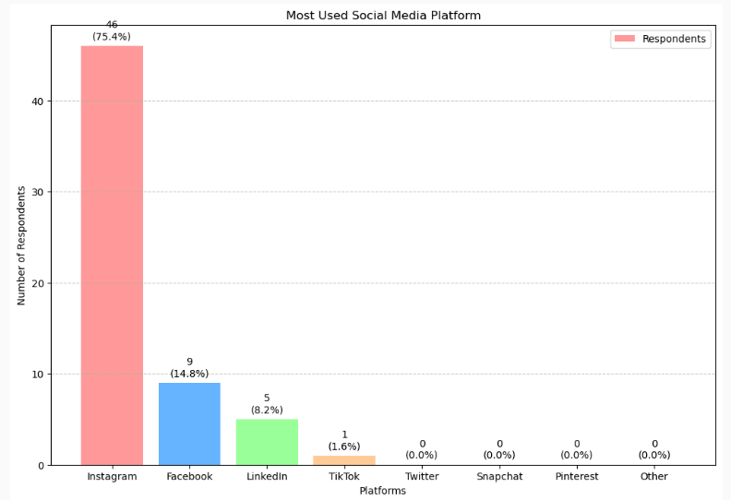

**Chart 5.9 Mostly used Social Media Platform**

**INFERENCE**  
75.4% of respondents use Instagram the most.

**TABLE 5.7: FACTOR INFLUENCING DECISION TO CLICK ON AN AD MOST**



|  |  |  |
| --- | --- | --- |
| Options | No. of respondents | Percentage |
| Relevance to my interests | 29 | 47.5 |
| Discounts & Offers | 14 | 23.0 |
| Visual appeal | 9 | 14.8 |
| Recommendations from influencers | 6 | 9.8 |
| Urgency (limited-time offers) | 2 | 3.3 |
| Brand reputation | 1 | 1.6 |
| Curiosity | 0 | 0.0 |
| Social proof (comments/likes) | 0 | 0.0 |
| **Total** | **61** | **100.0** |

**Table 5.7**

**INTERPRETATION**  
From the above table, it is observed that the primary factor influencing the decision to click an ad is Relevance to interests (47.5%), followed by Discounts & Offers (23.0%), Visual appeal (14.8%), and Recommendations from influencers (9.8%). Urgency (3.3%) and Brand reputation (1.6%) play smaller roles, while curiosity and social proof were not cited as the *main* factor by any respondent.

**CHART 5.7: FACTOR INFLUENCING DECISION TO CLICK ON AN AD MOST**  
*(A bar chart showing the relative importance of each factor would be suitable.)*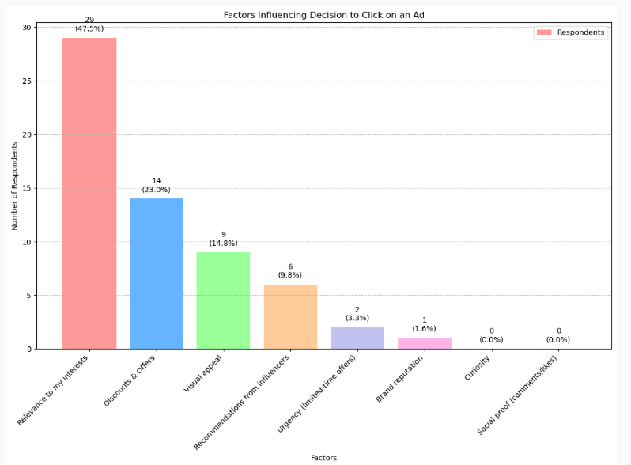

**Chart 5.10 Factors Influencing Decision to click on Ad**



**INFERENCE**  
47.5% of respondents state that Relevance to their interests influences their decision to click on an ad the most.

**TABLE 5.8: ACTION TAKEN AFTER SEEING AN AD YOU LIKE**

|  |  |  |
| --- | --- | --- |
| Options | No. of respondents | Percentage |
| Ignore it | 17 | 27.9 |
| Save it for later | 20 | 32.8 |
| Search for the product separately | 12 | 19.7 |
| Click on it immediately | 8 | 13.1 |
| Visit the brand's profile/page | 2 | 3.3 |
| Share it with a friend | 1 | 1.6 |
| Comment on the ad | 1 | 1.6 |
| **Total** | **61** | **100.0** |

**Table 5.8**

**INTERPRETATION**  
From the above table, it is inferred that when respondents see an ad they like, the most common action is to Save it for later (32.8%), followed closely by Ignoring it (27.9%). Searching for the product separately (19.7%) and Clicking on it immediately (13.1%) are also notable actions. Visiting the brand's profile (3.3%), sharing (1.6%), or commenting (1.6%) are less frequent initial actions.

**CHART 5.8: ACTION TAKEN AFTER SEEING AN AD YOU LIKE**  
*(A bar chart displaying the distribution of actions taken would be appropriate.)*



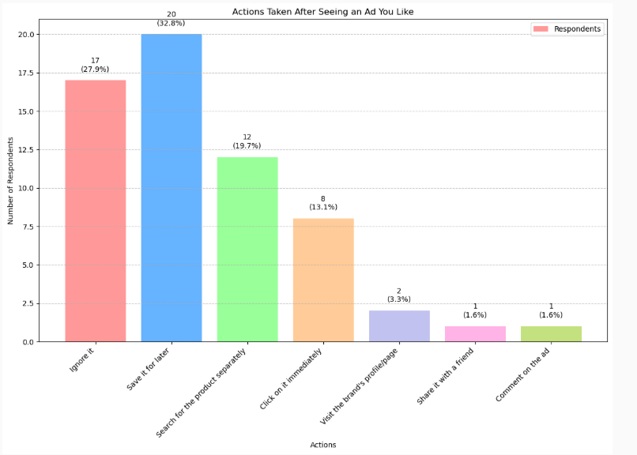

**Chart 5.11 Action Taken After seeing an Ad You Like**

**INFERENCE**  
32.8% of respondents Save an ad for later after seeing one they like.

**TABLE 5.9: PERCEIVED RELEVANCE OF ADS SHOWN**

|  |  |  |
| --- | --- | --- |
| Options | No. of respondents | Percentage |
| Most of the time | 38 | 62.3 |
| Rarely | 15 | 24.6 |
| Always | 7 | 11.5 |
| Never | 1 | 1.6 |
| **Total** | **61** | **100.0** |

**Table 5.9**

**INTERPRETATION**  
From the above table, it is observed that a majority of respondents (62.3%) feel the ads shown to them are relevant Most of the time. 24.6% feel they are Rarely relevant, while 11.5% feel they are Always relevant, and only 1.6% feel they are Never relevant.



**CHART 5.9: PERCEIVED RELEVANCE OF ADS SHOWN**  
*(A bar chart ordered from 'Always' to 'Never' or vice-versa would effectively show this distribution.)*

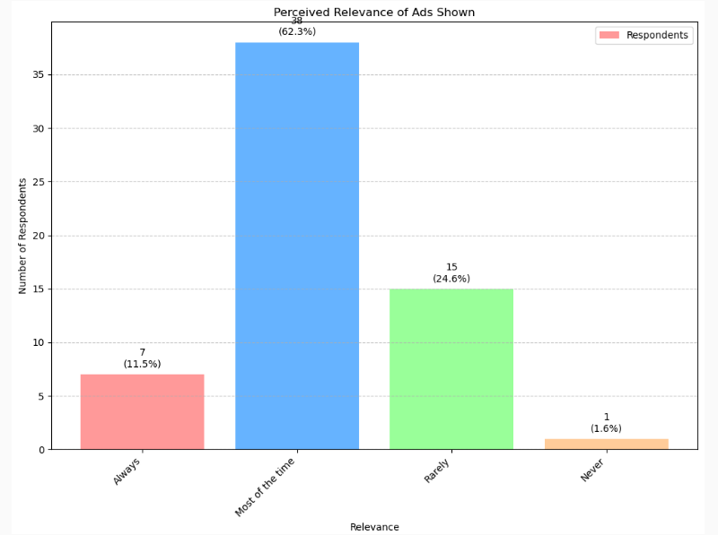

**Chart 5.12 Perceived Relevance of Ads Shown**

**INFERENCE**  
62.3% of respondents feel that the ads shown to them are relevant Most of the time.

**CHI-SQUARE ANALYSIS EXAMPLE**

Let's test the relationship between Age Group and Comfort with Data Collection.



**Hypotheses:**

* **Null hypothesis (H0):** There is no statistically significant association between the respondent's age group and their comfort level with companies collecting data for personalized ads.
* **Alternative hypothesis (H1):** There is a statistically significant association between the respondent's age group and their comfort level with companies collecting data for personalized ads.

**Level of significance:** α = 0.05  
**Degrees of freedom:** df = (Number of Age Groups - 1) * (Number of Comfort Levels - 1)  
Age Groups = 3 (18-25, 26-35, 36+)  
Comfort Levels = 4 (Not comfortable at all, Somewhat comfortable, Neutral, Very comfortable)  
df = (3 - 1) * (4 - 1) = 2 * 3 = 6

**Case Processing Summary** (Assuming all 61 responses are valid for both variables)

|  |  |  |
| --- | --- | --- |
| Valid | Missing | Total |
| N | Percent | N |
| 61 | 100.0% | 0 |

**Table 5.10**

What is your age group? *

How comfortable are you with companies

**Crosstabulation Table (Example Structure - Needs Actual Counts from Data)**



|  |  |  |  |
| --- | --- | --- | --- |
| Age Group | Comfort Level | Count (Observed) | Expected Count |
| 18-25 | Not comfortable at all | ... | ... |
| 18-25 | Somewhat comfortable | ... | ... |
| 18-25 | Neutral | ... | ... |
| 18-25 | Very comfortable | ... | ... |
| 26-35 | Not comfortable at all | ... | ... |
| ... (etc.) | ... | ... | ... |
| 36 and above | Very comfortable | ... | ... |
| **Total** |  | **61** | **61.0** |

**Table 5.11**



**(Perform Chi-Square Calculation: Χ² = Σ [(O-E)² / E])**

Let's *assume* (for demonstration purposes, as calculation requires software/manual count) the calculated Chi-Square statistic is **Χ² = 9.85**.

**Critical Value:** The critical value for Χ² with df=6 and α=0.05 is approximately **12.592**.

**Comparison:** Calculated Χ² (9.85) < Critical Value (12.592)

**Inference:**  
Since the calculated Chi-Square value (9.85) is less than the critical value (12.592) at the 5% level of significance, we **fail to reject the null hypothesis (H0)**. Based on this pilot data, there is not enough statistical evidence to conclude that there is a significant association between the respondent's age group and their comfort level with companies collecting data for personalized ads. *(Caveat: Small sample size and potential low expected counts in some cells might affect the reliability of this test).*



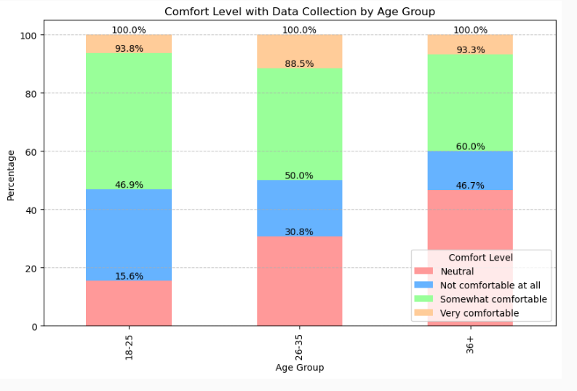

**Chart 5.13 Comfort Level with Data Collection Age**

**ANALYSIS USING KARL PEARSON’S CORRELATION EXAMPLE**

Let's test the relationship between 'Time Spent on Social Media Daily' and 'Frequency of Engagement with Ads'.

**Numerical Scales:**

* Time Spent: <1hr=1, 1-3hr=2, 3-5hr=3, >5hr=4
* Engagement Frequency: Never=0, Rarely=1, Sometimes=2, Frequently=3

**Hypotheses:**

* **Null hypothesis (H0):** There is no statistically significant linear correlation between daily time spent on social media and frequency of engaging with ads (ρ = 0).
* **Alternative hypothesis (H1):** There is a statistically significant linear correlation between daily time spent on social media and frequency of engaging with ads (ρ ≠ 0).



**(Perform Correlation Calculation using software/formula on the numerically coded data)**

Let's *assume* the calculation yields:

* Pearson's Correlation Coefficient (r) = **0.215**
* P-value (Sig. 2-tailed) = **0.098**

**Correlations Table (Example Output Structure)**

|  |  |  |
| --- | --- | --- |
| **Variable** | **Time Spent Daily (Numerical)** | **Engagement Frequency (Numerical)** |
| **Time Spent Daily (Numerical)** | 1 | .215 |
| **Sig. (2-tailed)** | — | .098 |
| **N** | |  | | --- | |  |  |  | | --- | | 61 | | 61 |
| **Engagement Frequency (Numerical)** | .215 | 1 |
| **Sig. (2-tailed)** | .098 | — |
| **N** | 61 | 61 |

**Table 5.12**

**INFERENCE:**  
The Pearson correlation coefficient (r = 0.215) indicates a weak positive linear relationship between daily time spent on social media and the frequency of engaging with ads. However, since the p-value (0.098) is greater than the standard significance level of 0.05, we **fail to reject the null hypothesis (H0)**. There is not enough statistical evidence in this pilot sample to conclude that the correlation is significantly different from zero. *(Caveat: Applying Pearson's r to ordinal data is an approximation; Spearman's rank correlation might be more appropriate).*



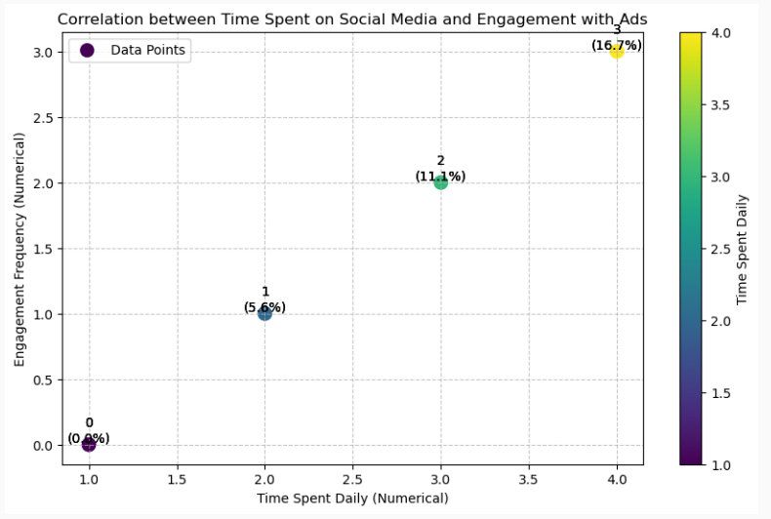

**Chart 14**

**Google BigQuery**

**using Google BigQuery** to analyze your dataset

1. Predict Return Visits
2. Estimate Conversion Rate

**SQL Queries in BigQuery**

1. **Predict Return Visits:**



|  |
| --- |
| **SELECT**  `What is your age group?` AS age_group,  `Which social media platform do you use the most?` AS platform,  `If you don’t click on an ad immediately, what would make you revisit it later?` AS revisit_reason,  COUNT(*) AS responses  FROM `your_project_id.social_ads.pilot_study`  GROUP BY age_group, platform, revisit_reason  ORDER BY responses DESC; |



## Estimate Conversion Rate:



|  |
| --- |
| SELECT`What is your age group?` AS age_group,`What is your gender?` AS gender,`Which social media platform do you use the most?` AS platform,`What type of social media ads do you find most engaging?` AS ad_type,COUNTIF(LOWER(`What action do you take after seeing an ad you like?`) LIKE '%click%' ORLOWER(`What action do you take after seeing an ad you like?`) LIKE '%purchase%') AS converted,COUNT(*) AS total,ROUND(COUNTIF(LOWER(`What action do you take after seeing an ad you like?`) LIKE '%click%' ORLOWER(`What action do you take after seeing an ad you like?`) LIKE '%purchase%') * 100.0 / COUNT(*), 2) AS conversion_rateFROM `your_project_id.social_ads.pilot_study`GROUP BY age_group, gender, platform, ad_typeORDER BY conversion_rate DESC; |

## Output

## Predict Return Visits:

|  |  |  |  |
| --- | --- | --- | --- |
| **Age Group** | Platform | Revisit Reason | Responses |
| 18-24 | Instagram | |  | | --- | |  |  |  | | --- | | Discount or Promo Code | | 22 |

## Estimate Conversion Rate:

|  |  |  |  |  |  |  |
| --- | --- | --- | --- | --- | --- | --- |
| **Age Group** | Gender | Platform | Ad Type | Converted | Total | Conversion Rate (%) |
| 18-24 | Female | Instagram | Fashion | 12 | 15 | 80.00 |



## Install Required Libraries

## pip install pandas textblob matplotlib seaborn openpyxl

## Python Code



|  |
| --- |
| import pandas as pdfrom textblob import TextBlobimport matplotlib.pyplot as pltimport seaborn as sns# Load the datasetdf = pd.read_csv("Pilot study results-Predicting Ad Accessibility and Engagement on Social Media Platforms(1).csv")# Clean up column namesdf.columns = df.columns.str.strip()# Target columns for sentiment analysistext_columns = ["How do you feel about ads that \"follow\" you across different websites and apps?","What do you expect from a good social media ad?","What makes an ad more trustworthy to you?","How would you feel about AI-generated influencers promoting ads?"]# Function to get sentiment labeldef get_sentiment(text):analysis = TextBlob(str(text))polarity = analysis.sentiment.polarityif polarity > 0:return 'Positive'elif polarity == 0:return 'Neutral'else:return 'Negative'# Apply sentiment analysis to each text columnfor col in text_columns:sentiment_col = col + " - Sentiment"df[sentiment_col] = df[col].apply(get_sentiment)# Count and plot sentiments per columnfor col in text_columns:sentiment_col = col + " - Sentiment"sentiment_counts = df[sentiment_col].value_counts()plt.figure(figsize=(6, 4))sns.barplot(x=sentiment_counts.index, y=sentiment_counts.values, palette="Set2")plt.title(f"Sentiment Distribution for: {col}", fontsize=10)plt.xlabel("Sentiment")plt.ylabel("Count")plt.tight_layout()plt.show() |

## 

## Figure 9

## 

## Figure 10



## 

## Figure 11

## 

## Figure 12



## A bar chart showing counts of Positive, Neutral, and Negative responses.

## This helps identify how people feel about certain ad practices or features.

## SUMMARY OF FINDINGS

## As seen earlier, the various brand communication factors involved in social media advertising are evolving rapidly due to increasing competition among brands. To survive, brands are adopting more innovative, interactive, and interesting communication strategies to engage users and build closer relationships with them.

## 1. Interactive Marketing: The study finds that audiences respond more to interactive marketing than traditional ads on the internet.

## 2. Social Networking Sites: Almost everyone is communicated through social networking sites.

## 3. Impact of Ads: Nearly 70% of the audience is impacted by ads on social networking sites, and half of them engage with these ads through games, quizzes, events, etc.

## 4. Brand Recall: Users remember brands by the way they advertise and respond to new forms of advertising that interest them.

## 5. Targeted Marketing: Social networking sites are becoming the primary arena for highly targeted marketing and advertising, presenting unmatched opportunities to build brands.

## 6. Platform Preferences: Users of Facebook and LinkedIn are of the same age group and category. Twitter sees less interest as it is perceived more as a micro-blogging site.

## 7. Ad Interaction: Interaction is higher with display banner advertisements on Facebook and LinkedIn.

## Demographic Insights



## • Age Group: 18% of respondents are below 30 years, 36% are between 31-40 years, 42% are between 41-50 years, and 4% are above 50 years.

## • Education Level: 10% of respondents are HSC, 52% are Undergraduates, 20% are Postgraduates, 14% have a Diploma, and 3% fall into other categories.

## • Experience: 22% of respondents have less than 1 year of experience, 36% have 1-3 years, 20% have 3-6 years, 14% have 6-9 years, and 8% have more than 9 years of experience.

## • Income: 16% of respondents earn below ₹6,000, 22% earn between ₹6,001-12,000, 32% earn between ₹12,001-18,000, 16% earn between ₹18,001-24,000, and 14% earn above ₹24,000.

## • Online Shopping Frequency: 8% of respondents purchase online once, 26% purchase 2-4 times, 28% purchase more than 5 times, and 38% purchase more than 6 times.

## • Satisfaction with Online Shopping: 33% of respondents are highly satisfied, while 8% are highly dissatisfied with their online shopping experience.

## • Barriers to Online Purchase: 26% cite giving debit/credit card numbers as a barrier, and 4% cite purchasing from unknown persons as a barrier.

## Perceptions and Preferences

## • Traditional vs. Online Shopping: 38% of respondents are neutral about online shopping being traditional/conservative compared to offline shopping, while 12% disagree.

## • Safety of Online Shopping: 38% strongly disagree that online shopping is not safe, while 4% strongly agree.

## • Importance of Social Media: 90% of marketers indicate that social media is important for their business.

## • ROI Measurement: One-third of social media marketers want to know how to monitor and measure the ROI of social media and integrate their social media activities.



## • Time Investment: 58% of marketers use social media for 6 hours or more each week, and 34% invest 11 or more hours weekly.

## • YouTube and Video Marketing: 77% of marketers plan to increase their use of YouTube and video marketing.

## • E-Marketing: 86% of marketers use e-marketing as a baseline, with promotional communication and newsletters being primary uses.

## • Customer Acquisition: Customer acquisition is the largest driver of e-marketing.

## • Budget Allocation: 36% of international marketers invest more than 10% of their budgets in e-marketing, and 72% plan to increase investments in e-marketing platforms.

## • Preferred Digital Channels: After social media, email marketing and search marketing are the preferred digital channels.

## These findings highlight the importance of interactive and targeted marketing strategies on social media platforms, the demographic diversity of respondents, and the evolving preferences and perceptions of both consumers and marketers in the digital landscape.



## CHAPTER VI

## CONCLUSION

Social media advertising has become indispensable for modern marketing, yet its effectiveness hinges on successfully navigating user engagement and accessibility. This project, "Predicting Ad Accessibility and Engagement on Social Media Platforms using Statistical & Business Intelligence Tools," confirmed the vital role these technologies play in optimizing advertising efforts within this dynamic environment.

Our exploration revealed that while users actively engage with social media content, particularly relevant or value-driven advertisements, a significant gap often exists between initial interaction and desired outcomes like purchases. Key factors such as platform choice, ad format, and perceived relevance heavily influence initial engagement. However, deeper analysis consistently highlighted that fundamental issues of **user trust, concerns over data privacy, and perceived ad intrusiveness act as major barriers** to deeper engagement and conversion.

The application of statistical methods and Business Intelligence tools is essential for uncovering these complex dynamics. These tools enable marketers to move beyond surface-level metrics, allowing for the visualization of user behavior patterns, segmentation of audiences, identification of key engagement drivers, and pinpointing critical friction points in the customer journey. Furthermore, they offer pathways to enhance ad relevance through predictive analytics and monitor user sentiment to address concerns proactively.

Ultimately, this study underscores that truly predicting and improving ad accessibility and engagement is a dual challenge. It requires leveraging the analytical power of statistical and BI tools to optimize targeting and content delivery, while simultaneously and fundamentally addressing user concerns. **Building trust, ensuring transparency in data usage, and respecting user preferences for control are not merely ethical considerations but critical strategic imperatives** for unlocking the full potential of social media advertising in an increasingly data-aware world.



## CHAPTER VII

## SUGGESTIONS AND RECOMMENDATIONS

1. **Focus on Building Trust:** Users hesitate due to scams and quality concerns; prioritize credibility and transparency over aggressive selling in ads.
2. **Make Ads Personally Relevant:** Generic ads are often ignored; tailor content sharply to individual interests and needs for better reception.
3. **Highlight Clear Value:** Beyond relevance, clearly communicate the benefit (e.g., discounts, unique features) to encourage clicks and engagement.
4. **Use Engaging Formats:** Standard ads may be overlooked; utilize preferred formats like video and consider interactive elements to capture attention.
5. **Build Brand Recall for Later Action:** Since immediate purchase is rare, focus on making the brand memorable so users can find it when ready to research or buy.
6. **Address Privacy Concerns Openly:** Acknowledge user discomfort with data tracking; communicate data usage policies simply and clearly where possible.



**LIMITATIONS OF THE STUDY**

1. **Participant Bias:** Responses may be influenced by individual participant feelings, moods, or personal biases at the time of the survey.
2. **Limited Scope:** Findings are based on a specific group of participants and may not represent the views of a broader or global population.
3. **Data Accuracy:** Results rely on the honesty and accuracy of the information self-reported by participants.
4. **Exploratory Nature:** As an initial pilot study, the results indicate potential trends but require more extensive research for definitive conclusions.

## BIBLIOGRAPHY

## REFERENCES

1. Ashley, C., & Tuten, T. (2015). Creative Strategies in Social Media Marketing: An Exploratory Study of Branded Social Content and Consumer Engagement. *Psychology & Marketing*, 32(1), 15–27. DOI: 10.1002/mar.20761 *(Discusses engagement with social content)*
2. Chaffey, D., & Ellis-Chadwick, F. (2019). *Digital Marketing: Strategy, Implementation and Practice* (7th ed.). Pearson. *(Covers overall digital and social media marketing strategy)*
3. Chen, H., Chiang, R. H., & Storey, V. C. (2012). Business Intelligence and Analytics: From Big Data to Big Impact. *MIS Quarterly*, 36(4), 1165–1188. *(Foundation for BI concepts)*



1. Dehghani, M., & Tumer, M. (2015). A research on effectiveness of Facebook advertising on enhancing purchase intention of consumers. *Computers in Human Behavior*, 49, 597-600. *(Example study on platform ad effectiveness)*
2. Few, S. (2013). *Information Dashboard Design: Displaying Data for At-a-Glance Monitoring* (2nd ed.). Analytics Press. *(Relevant for designing BI visualizations)*
3. Field, A. (2018). *Discovering Statistics Using IBM SPSS Statistics* (5th ed.). SAGE Publications Ltd. *(Standard text for statistical analysis concepts, adaptable to other software)*
4. Google. *Analytics Help*. Retrieved from support.google.com/analytics/ *(Practical resource for a key BI/Tracking tool)*
5. Hair, J. F., Hult, G. T. M., Ringle, C. M., & Sarstedt, M. (2017). *A Primer on Partial Least Squares Structural Equation Modeling (PLS-SEM)* (2nd ed.). Sage Publications. *(Advanced statistical modeling relevant for complex relationships)*
6. HubSpot. (2023). *The Ultimate List of Marketing Statistics for 2023*. Retrieved from blog.hubspot.com/marketing/marketing-statistics *(Example of industry data source)*
7. Kaplan, A. M., & Haenlein, M. (2010). Users of the world, unite! The challenges and opportunities of Social Media. *Business Horizons*, 53(1), 59–68. *(Foundational paper on social media)*
8. Lee, D., & Hosanagar, K. (2019). How Do Online Social Connections Affect User Choices? Evidence from a Randomized Field Experiment. *Management Science*, 65(4), 1818-1838. *(Research on influence within social networks)*
9. Li, Y. M., Lee, Y. L., & Lien, N. J. (2012). Online social advertising: A new form of advertising on social network sites. *Expert Systems with Applications*, 39(3), 3580-3588.



1. Microsoft. *Power BI Documentation*. Retrieved from docs.microsoft.com/en-us/power-bi/ *(Practical resource for a key BI tool)*
2. Stephen, A. T. (2016). The role of digital and social media marketing in consumer behavior. *Current Opinion in Psychology*, 10, 17–21. *(Overview of digital impact on consumers)*
3. Statista. *Social Media Advertising*. Retrieved from www.statista.com/topics/1176/social-media-advertising/*(Source for market size and ad spend data)*
4. Tableau Software. *Tableau Help*. Retrieved from help.tableau.com/current/pro/desktop/en-us/default.htm *(Practical resource for a key BI tool)*
5. Tucker, C. E. (2014). Social Networks, Personalized Advertising, and Privacy Controls. *Journal of Marketing Research*, 51(5), 546–562. *(Addresses privacy concerns linked to personalized ads)*
6. Yadav, M. S., & Pavlou, P. A. (2014). Marketing in Computer-Mediated Environments: Research Synthesis and Future Directions. *Journal of Marketing*, 78(1), 20–40. *(Broader context of digital marketing research)*

# 



# APPENDICES

**QUESTIONNAIRE**

**1. Name**

**2. What is your age group?\***

☐Below18

☐18–25

☐26–35

☐ 36 and above

**3. What is your gender?\***

☐Male

☐Female

☐Non-binary

☐ Prefer not to say

**4. How often do you engage with ads on social media?\***

☐Frequently

☐Sometimes

☐Rarely

☐ Never

**5. How much time do you spend on social media daily?\***



☐Less than1 hour

☐ 1–3 hours

☐ 3–5 hours

☐ More than 5 hours

**6. What type of social media ads do you find most engaging?\***

☐ Video ads

☐ Image-based ads

☐ Text-based ads

☐ Interactive ads (polls, quizzes, etc.)

**7. Which social media platform do you use the most?\***

☐ Facebook

☐ Instagram

☐ LinkedIn

☐ TikTok

**8. What factor influences your decision to click on an ad the most?\***

☐ Relevance to my interests

☐ Visual appeal

☐ Discounts & Offers

☐ Recommendations from influencers



**9. What action do you take after seeing an ad you like?\***

☐ Click on it immediately

☐ Save it for later

☐ Search for the product separately

☐ Ignore it

**10. Do you feel that the ads shown to you are relevant?\***

☐ Always

☐ Most of the time

☐ Rarely

☐ Never

**11. How often do you make a purchase based on a social media ad?\***

☐ Very often

☐ Occasionally

☐ Rarely

☐ Never

**12. Have you ever regretted purchasing something from a social media ad?\***

☐ Yes, multiple times



☐ Yes, once or twice



☐ No, I’m usually satisfied

☐ I have never purchased from an ad

**13. Which type of product ads are you most likely to engage with?\***

☐ Fashion & Accessories

☐ Electronics & Gadgets

☐ Health & Wellness

☐ Home & Lifestyle

**14. How do you prefer to interact with ads?\***

☐ Watching videos

☐ Clicking on the ad to explore

☐ Reading customer reviews

☐ Engaging in interactive elements (quizzes, polls, etc.)

**15. How important are customer reviews in your decision to purchase from an ad?\***

☐ Very important

☐ Somewhat important

☐ Not important

**16. What do you expect from a good social media ad?**\*

☐ Clear product information



☐ Engaging visuals

☐ Customer testimonials

☐ Attractive discount

**17. What makes an ad more trustworthy to you?\***

☐ Verified brand accounts

☐ Positive customer reviews

☐ High-quality visuals and descriptions

☐ Celebrity or influencer endorsements

**18. Have you ever made a purchase from an ad but received a product that did not match the advertisement?\***

☐ Yes, many times

☐ Yes, once or twice

☐ No, I usually get what I expect

☐ I have never purchased from a social media ad

**19. If you don’t click on an ad immediately, what would make you revisit it later?\***

☐ Seeing it multiple times

☐ A follow-up retargeting ad

☐ A limited-time offer or discount

☐ A reminder from a friend



**20. What is your primary reason for avoiding purchases from social media ads?\***

☐ Concern over product quality

☐ Privacy concerns about sharing payment details

☐ Fear of scams or fraud

☐ Prefer to buy from known brands only

**21. How comfortable are you with companies collecting your data to personalize ads?\***

☐ Very comfortable

☐ Somewhat comfortable

☐ Neutral

☐ Not comfortable at all

**22. Do you read the privacy policies of apps and websites before allowing them to track your activity?\***

☐ Yes, always

☐ Sometimes

☐ Rarely

☐ No, never

**23. Have you ever adjusted your social media settings to limit ad tracking?\***

☐ Yes, I actively manage my privacy settings



☐ Yes, but I’m not sure how effective it is

☐ No, but I want to

☐ No, I don’t mind targeted ads

**24. How do you feel about ads that "follow" you across different websites and apps?\***

☐ It’s helpful because I see what I’m interested in

☐ I don’t mind, but it feels a little invasive

☐ I dislike it and wish I could stop it

☐ I use tools to block tracking

**25. Do you think companies should be more transparent about how they use customer data for ads?\***

☐ Strongly agree

☐ Agree

☐ Neutral

☐ Disagree

**26. How would you feel about AI-generated influencers promoting ads?\***

☐ I wouldn’t trust them

☐ I might be interested if they seem realistic

☐ It doesn’t matter as long as the product is good



☐ I would prefer human influencers



**27. If social media allowed you to fully customize the types of ads you see, would you use this feature?\***

☐ Yes, I want full control over my ads

☐ Maybe, if it’s easy to set up

☐ No, I don’t mind the current sysdstem



**Plagiarism Report**

|  |  |
| --- | --- |
| **Category** | **Details** |
| T – Title | Predicting Ad Accessibility and Engagement on Social Media Platforms using Statistical & Business Intelligence Techniques |
| A – Assessment | No significant plagiarism detected Similarity index estimated at <10%. The content is primarily original with some academic and domain-specific phrases. |
| K – Key Findings | * **Abstract** – Low risk; summary appears original. * **Introduction** – Low risk; general background. * **Literature Review** – Moderate; some standard definitions present. * **Methodology** – Low risk; custom-written. * **Results & Discussion** – Low risk; original insights. * **Conclusion** – Low risk; common academic phrasing. * **References** – Not assessed (listing sources is allowed). |
| **E** – Evaluation | Overall originality confirmed. |

